Mentor Bios!

Anne Neo Hui Ting

Anne Neo Hui Ting
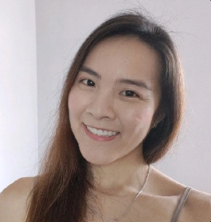
Licensed Pharmacist, Centre Manager (Active Ageing Centre) at Lions Befrienders Service Association, Founder and CEO (The Giving Collective)

Bio: Worked as a pharmacist in a public healthcare institutions for 6 years before moving on to social care sector as a centre manager in an active ageing centre, curating programmes and stakeholder communications across various sectors- healthcare, politicians, town council,corporate partners. Served on the EXCO for the Society of Behavioural health Singapore, organising conferences, workshops and advocating for person centred care and lifestyle medication in addition to medication awareness in improving health outcomes in the local and international landscape.

Somewhere along the way, started my own ground up initiative, to give back to the community through food distribution to low income families and elderly, providing health talks pro bono at homeless shelters and other Active ageing centres and brightening public spaces through mural painting and creative art expression.

Currently pursuing a masters in public health at NUS to broaden perspectives related to health and social care, with a special interest in social determinants of health, health behaviour and communication and comparative health policies across national borders.

Interest areas: Health literacy, health and wellbeing, underserved/less privileged populations (youths/seniors/families)

Area of contribution: Value proposition, real world experience, perspectives at the meeting point between health and social care.

Shyam

Shyamsundar Venkataraman (Shyam)
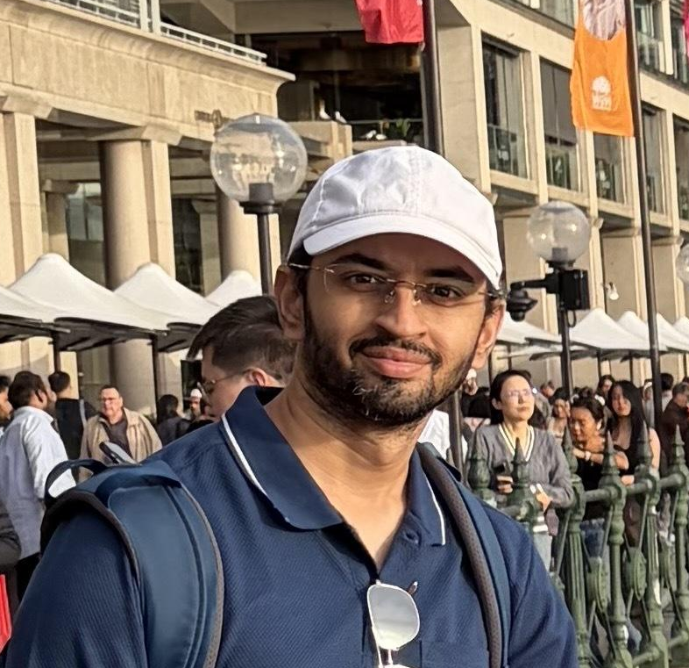

Engineering Manager, Open Government Products

Bio: Been a software engineer most of my life and love building and automating tedious work. Have worked at startups and big tech and decided to build for public good for the last few years. Worked on Bright, a referral management system used by AIC for referring patients in the ILTC (Intermediate to Long Term Care) sector. Was also recently working with the RefX team to launch Referral Exchange, to help digitise patient referrals from GPs to specialist clinics across Singapore.
Happy to help teams with anything engineering or product related.

Levonne Goh

Levonne Goh
MPH Class of 2025, NUS
Manager, Centre for Impact Investing and Practices, Temasek Trust
Volunteer, TriGen

Bio: Levonne has years of experience across public and philanthropy sectors. She started her career at Enterprise Singapore, the local government agency championing enterprise development, where she helped to engage and support healthcare and biomedical companies to grow and internationalise.

Levonne holds a Bachelor of Arts (Honours) in Southeast Asian Studies from the National University of Singapore, as well as a Master in Public Health from the Saw Swee Hock School of Public Health. She will be embarking on a PhD with the University of Queensland in January 2027, where her research focuses on youth development. She is also an avid language learner, with intermediate to advanced proficiency in Japanese, Korean, and Thai.

Currently, Levonne is with the Centre for Impact Investing and Practices (CIIP), an entity within Temasek Trust. Her work entails research into impact investing opportunities and programme translation, focusing on areas such as sustainable agriculture and climate adaptation. Outside of CIIP, Levonne is an active youth leader and volunteer. She was the President for AIESEC Singapore, the local chapter of the world's largest youth-run organisation. Since 2021, she has also been with the Global Shapers Community, an initiative of the World Economic Forum to engage active changemakers across the world. She is also part of the Research team at TriGen, where she is supporting the evaluation of the inaugural Health Youth Leaders Programme (HYLP)

Imran Shah

Imran Shah
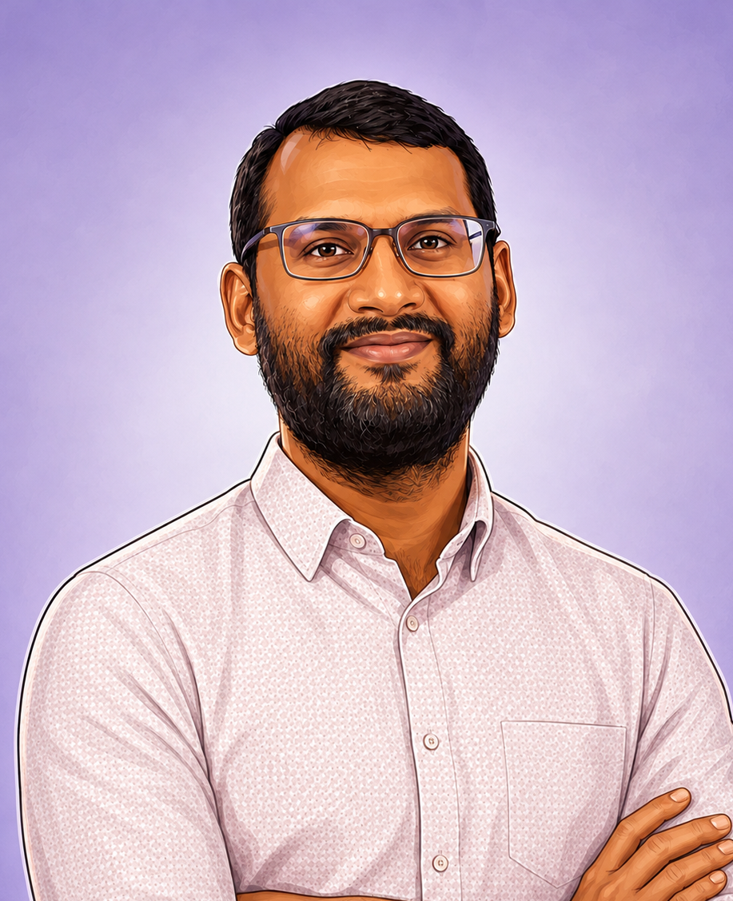
Title
Pharmacist & Healthcare Operator | Managing Director, Alami Clinic
What I do
I am a pharmacist and Managing Director of Alami Clinic, a community-based geriatric practice. My work spans clinical pharmacy, healthcare operations, service development and business strategy. I continue to practise in oncology pharmacy while building and running community healthcare services. I am particularly interested in translating good clinical ideas into practical services that work for patients, caregivers and healthcare teams.
Interest areas
Clinical pharmacy · Medication safety · Geriatric and community care · Oncology · Caregiver support · Healthcare operations · Service design · Healthcare entrepreneurship · Patient access · Sustainable models of care
Where I would like to contribute as a mentor
I would be most useful to teams that need a healthcare reality check: understanding the actual problem, testing whether a proposed solution fits clinical workflows, identifying implementation or safety issues, and thinking through how an idea could move from prototype to something patients and healthcare teams would genuinely use. I can also contribute on medication-related problems, community care, geriatric care, patient access and healthcare business models.

Vivian Kee Jie Yi

Vivian Kee Jie Yi
Title
Senior Acupuncturist, Singapore General Hospital | TriGen HealthStart Committee | HomeCare Mentor
What I do
I am a clinician with interests in community health, healthy ageing, integrative medicine, and healthcare innovation. Beyond clinical practice, I lead community outreach initiatives through TriGen HealthStart and mentor volunteers in HomeCare programmes, working to bridge healthcare, social care, and the community. I am also actively involved in healthcare innovation and research, supporting Epic workflow optimisation, digital health initiatives, and technology-enabled solutions that improve care delivery and patient outcomes.
Interest Areas
Community Health • Healthy Ageing • Preventive Care • Healthcare Innovation • Digital Health • Integrative Medicine • Service Design • Volunteerism • Population Health
How I can contribute as a mentor:
I enjoy helping teams validate healthcare problems, understand patient and stakeholder needs, and translate ideas into practical, implementable solutions. I can contribute perspectives on community care, volunteer-led programmes, healthcare operations, patient engagement, and real-world implementation.

Lum Zheng Kang

Lum Zheng Kang

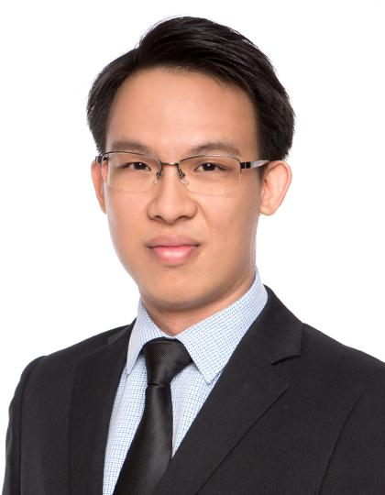
CEO and Founder, Collabring Pte. Ltd.
Chairperson, Training Academy, Pharmaceutical Society of Singapore
Advisor (Medical), Renal Health Services

WHAT I DO
I am a pharmacist and health services researcher whose work focuses on translating clinical evidence into practical healthcare programmes that improve outcomes. I am the Founder and CEO of Collabring, a healthcare implementation company that works with healthcare organisations, professional associations, industry partners and academic institutions to design, implement and evaluate healthcare services across Asia and Europe. My work spans implementation research, person-centred care, health literacy, and service innovation. I also serve as Chairperson of the Training Academy at the Pharmaceutical Society of Singapore and Medical Advisor to Renal Health Services Ltd., supporting professional education, community-based care and renal health projects.

INTEREST AREAS
Implementation · Health services research · Person-centred care · Health literacy · Heart-brain connection · Renal health · Interprofessional care · Service design · Programme evaluation

WHERE I WOULD LIKE TO CONTRIBUTE AS A MENTOR
I would like to contribute to teams working on healthcare problems where understanding the patient, clinical context and real-world implementation is critical. I can help with problem definition, identifying unmet needs, challenging assumptions, clinical and operational workflow analysis, stakeholder perspectives, solution feasibility, implementation strategy and evaluation. I am particularly interested in helping teams bridge the gap between an innovative idea or prototype and a solution that can realistically be adopted and sustained in healthcare practice.

Desmond Teo

Desmond Teo

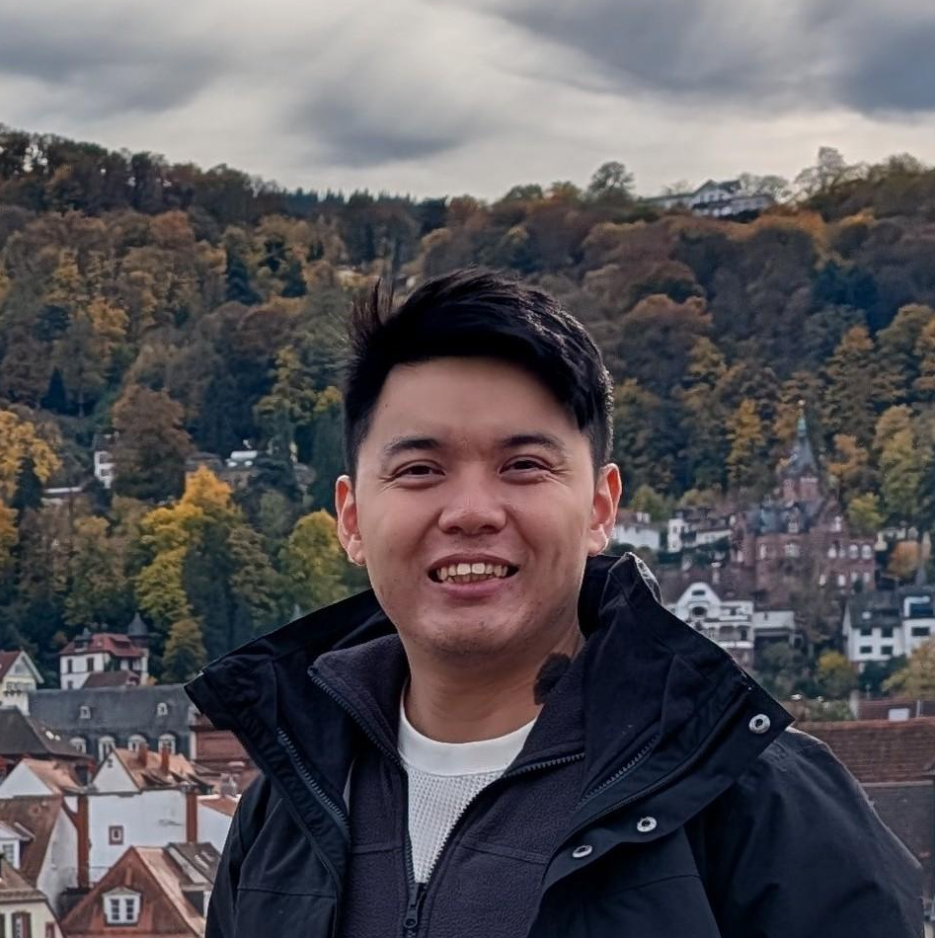
Product Manager & Pharmacist, Pharmacy Automation
Swisslog Healthcare
Started my career as a pharmacist at the National University Hospital, and always had a deep interest in technology. I eventually made the leap into healthcare data and analytics, where I built AI and automation solutions to support public health and medication safety.
Through building these solutions, I realised that great technology alone is not enough - it also needs strong product thinking to ensure we are solving the right problems in a way that creates real impact. Today, I work as a Product Manager at Swisslog Healthcare, leading product strategy and development for pharmacy automation solutions across global markets.
I'm particularly interested in working at the intersection of healthcare and clinical workflows, technology, and AI.
Happy to help teams with anything related to technical development and product management - from framing and validating problem statements through market research and user interviews, to defining, scoping and prioritising features, product prototyping, and software development and testing / evaluation.

Yong Cheng Low

Yong Cheng Low (YC)

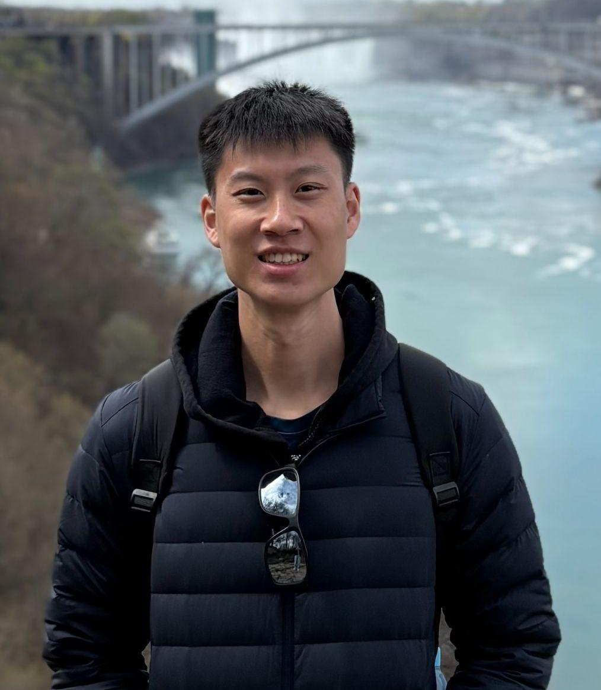
Title
Software Engineer at National University Health System Artificial Intelligence Office
What I do

I build AI systems at NUHS, working on LLMs and voice applications. I joined through NUH's Department of Medicine Innovation Office, so my work includes requirements gathering, market research, setting up the development platform, shipping and running the system. Recent products include an AI-assisted medical coding tool, a speech-to-speech agent, setting up and usage of metabase and an authentication service. Before healthcare, I was at Glints, a recruitment startup, leading the technical team behind its recruiter products.
Interest areas
I am drawn to the parts of clinical AI where the engineering is genuinely hard such as:
- Orchestrating multi-step agentic systems and knowing where they can safely assist
- Voice agents that take information from patients directly
- Getting models to reason over records far longer than their context window
- Evaluating output well enough to satisfy a regulated environment
- How to build and run products that are scalable on cloud with minimal cost while adhering to strict regulations
Where I would like to contribute as a mentor
I am happy to help teams with technical product management, understanding requirements and their clinical background, running market research, identifying the north star metric, and drawing out the technical architecture underneath. Scoping and architecture done together rather than handed between people.

Alistair Norris
Alistair Norris
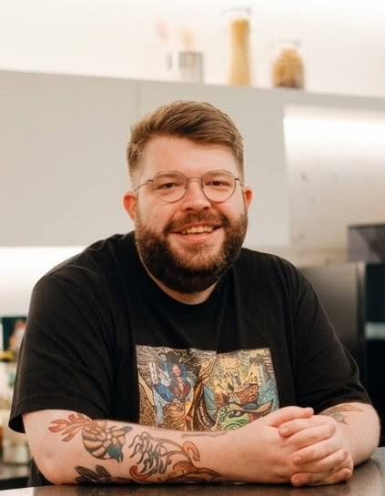
HealthTech Design Lead, Open Government Products
What I do
I’m a designer and researcher with experience across healthcare, eldercare and social services. At Agency and my own studio, brief., I worked on projects exploring care, ageing and how people live together. Now I lead HealthTech Design at OGP, supporting the team across our healthcare products and helping shape their direction. My work brings together research, idea generation and rapid prototyping to help teams explore possibilities and learn what works.
Interest areas
Ageing, end-of-life care, and the experiences of patients, families, carers and frontline staff.
Where I can help
Understanding care journeys, planning research, generating ideas and building quick prototypes to test them. I can help your team find a manageable starting point, work through different approaches, and consider how an idea would fit into people’s lives and existing services.

Andrew Ho

Andrew Ho
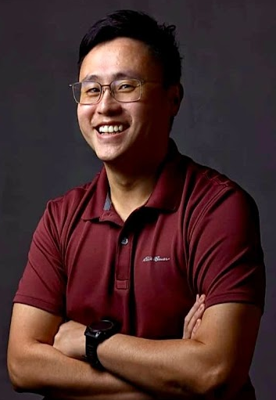

Emergency Physician & Clinician Researcher, Singapore General Hospital

What I do
I am an Emergency Physician by training and work as a specialist in the Emergency Department of Singapore General Hospital. I also spend half my working time on research, where I currently focus on how to use artificial intelligence to solve healthcare problems in ways that are fair, trustworthy and clinically meaningful. I am particularly interested in the space where algorithms meet real patients, real clinicians, and real-world complexity.

Interest Areas
Artificial intelligence, emergency medicine, cardiovascular emergencies, resuscitation, population health

Where I would like to contribute as a mentor
I could perhaps lend a lens into the messy real world healthcare setting

Malcolm Tan
Malcolm Tan

What I do
I’m a practising Gastroenterologist with an interest in inflammatory bowel disease.

Interest Areas
Inflammatory bowel disease, endoscopy, public health.
Where I would like to contribute as a mentor
I’m not sure, still figuring things out.

Petrina Yeow

Petrina Yeow
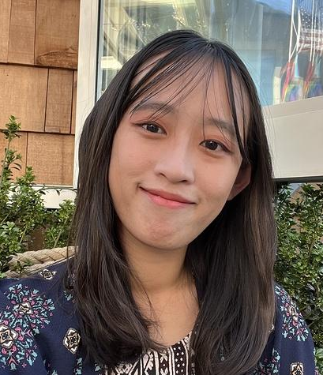

Product Manager, Open Government Products
I studied Psychology and broke into tech the long way round: six internships, multiple hackathons and a lot of self-learning. That path took me through various jobs in digital marketing, branding and customer success before landing on Product. I started as a Product Designer at DBS, then moved into Product Management, and now build public products at OGP, working on various products like ActiveSG, AskGov and Maps. Outside of work, I co-founded Work Live Digital, teaching seniors computer skills that the rest of us take for granted.
Happy to help teams with problem definition, solution ideation, product strategy and UX.

Mary-Anne Phang

Mary-Anne Phang
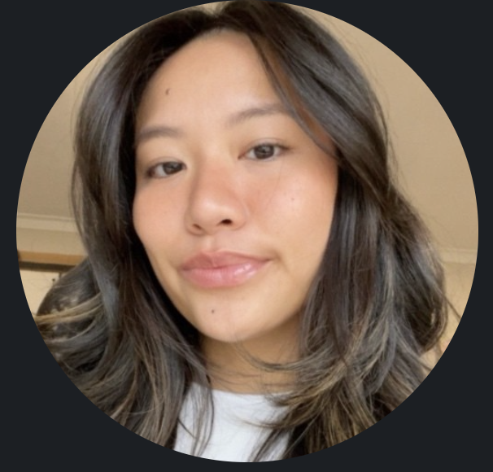
Registered & Practicing Occupational Therapist at Rocky Bay Community Disability, Paediatric, Youth and Adult Neurodiverse-affirming, Strengths-Based practice and Disability-Inclusion advocate, Parent and Family-Centred Coaching, Clinical-Therapy Mentor, Autism and Disability researcher. Member of the Western Australian Occupational Therapy Association.

What I do
Mary-Anne Phang is an Australian Health Practitioner Regulation Agency registered and practicing Occupational Therapist. Besides her professional qualification, she has lived experience in neurodiversity and extensive experience supporting neurodivergent individuals across the lifespan, from early childhood through adulthood, extending to parent coaching.
With a strong interest in community disability and advocacy, Mary-Anne is passionate about self-discovery, meaningful participation, mental health and positive self-identity. She has supported individuals, families, educators and key stakeholders through clinical practice and educational programs, while also contributing to autism research in Australia. Mary-Anne is currently contributing to a body of ongoing research targeting accessibility to justice in Singapore, from an occupational and holistic perspective.
With strong experiences in supporting people with invisible, intellectual, cognitive and neuro-developmental disabilities in Singapore and Australia, Mary-Anne integrates strengths-based, family and person centred, trauma informed approaches of neurodiversity-affirming occupational therapy to promote inclusion, participation and meaningful engagement, on all tiers of healthcare, community and everyday participation.

Interest areas
Neurodiverse-affirming practices, language and integration, Mental Health and Neurodiverse crossovers, Therapeutic Interventions, Inclusive Justice for People with Complex Support Needs, Eating Disorders, Early Intervention, Neuro-developmental disorders and delays, Autism and disability research, Health Literacy and Societal inclusion within Neurodiverse groups.

What i would like to contribute as a mentor
Neuro-inclusion advocacy, Lived experienced, Therapeutic and allied health mentorship, Cognitive, Environmental and Occupational Integration, Intervention and community program development, caregiver/support staff training and education, Upstream work mentorship

Julian Koo

Julian Koo
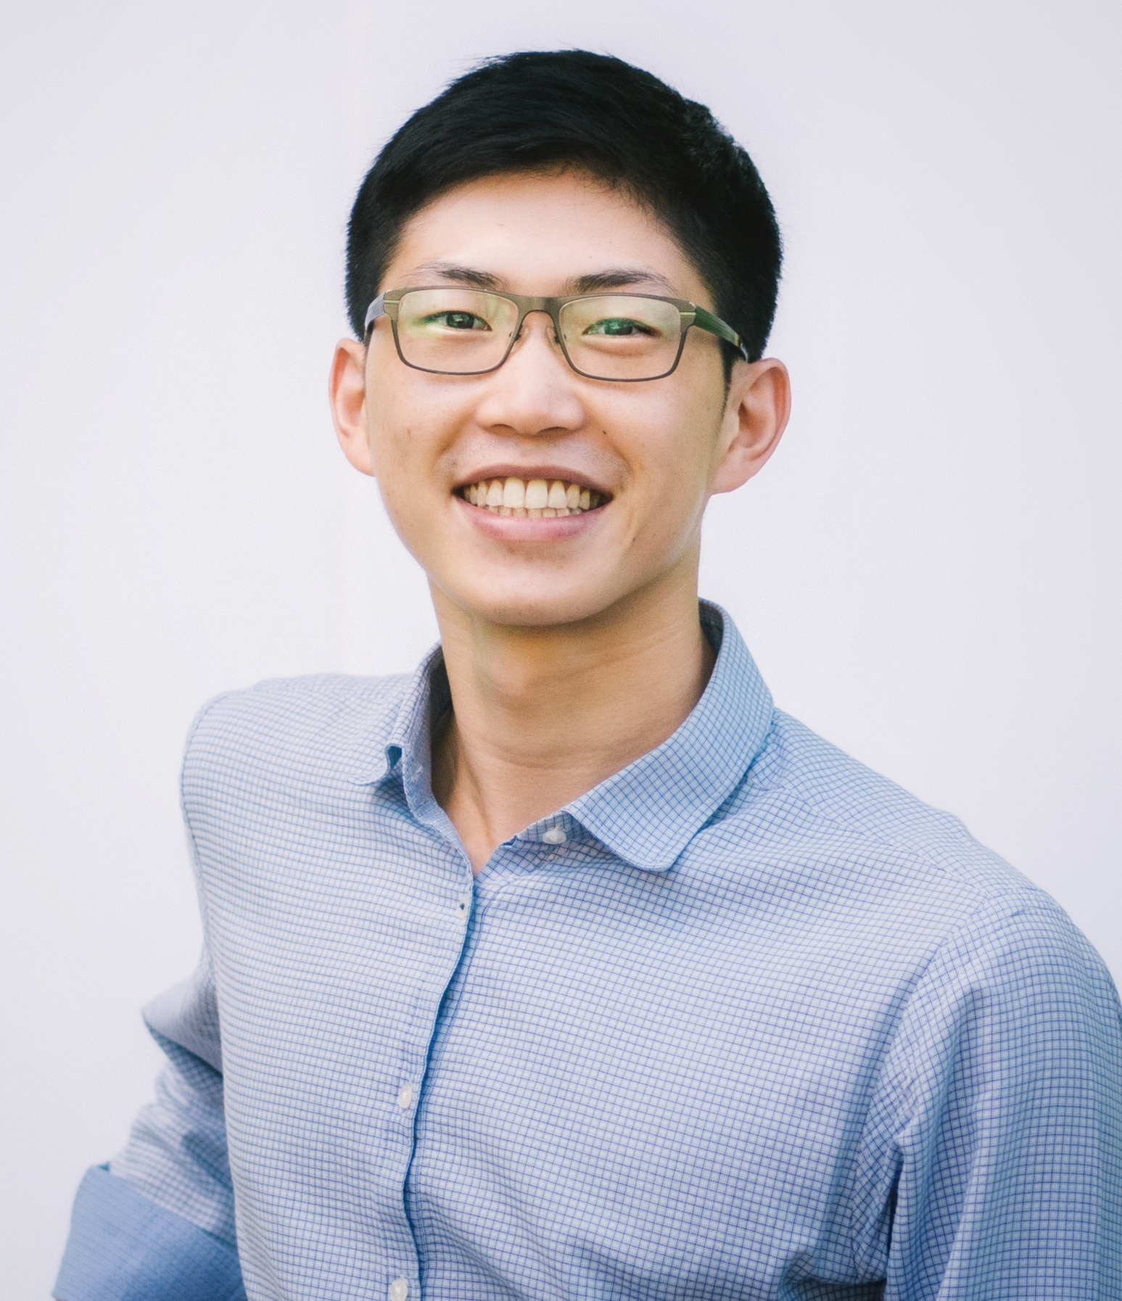
What I do
Julian is a digital health entrepreneur who enjoys working on impactful problems in health and medtech. He co-founded Jaga‑Me, a digital home health platform that grew from an idea to serving over 50,000 patients. Julian also advises clinician and corporate leaders on venture creation, commercialization and acquisitions.
Interest areas
Product and Business model innovation.
What I would like to contribute as a mentor
Problem definition. Product building. Startup venture creation. Commercialization.

Ng Tat Ming

Ng Tat Ming
`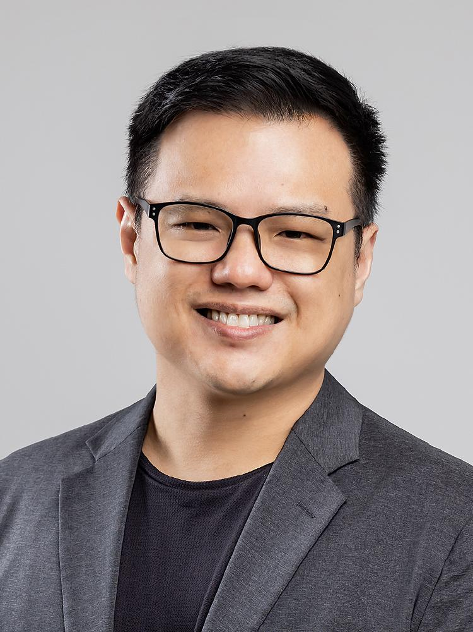
I’m an experienced pharmacist and clinical leader at Tan Tock Seng Hospital with an interest in advancing clinical care through research and innovation, I also serve a faculty at the Centre for Health Innovation, NHG Health. Working as a council member of the Pharmaceutical Society of Singapore,I started HackitRx Singapore with a small team of like minded pharmacists to build a platform for innovators of diverse backgrounds to come together to address local challenges in health and healthcare.
Interest areas
Value-based care, Artificial Intelligence and clinical service development
What i would like to contribute as a mentor

I can help teams with problem statement development, design research and questions on the public healthcare system and pharmacy practice in Singapore.

Daniel Lim

Daniel Lim

What I do
I am a gastroenterologist with an interest in liver disease and data science for healthcare. My teams have won prior local hackathons (first place at Singapore Healthcare AI Datathon and Expo 2022)

Interest Areas
Liver disease, fatty liver, AI/data science for healthcare
Where I would like to contribute as a mentor
I can help teams understand healthcare problems on the ground and what technology solutions currently exist. I can help teams work through design choices in their product development to increase validity and usability for healthcare.

Lou Huei Xin

Lou Huei Xin

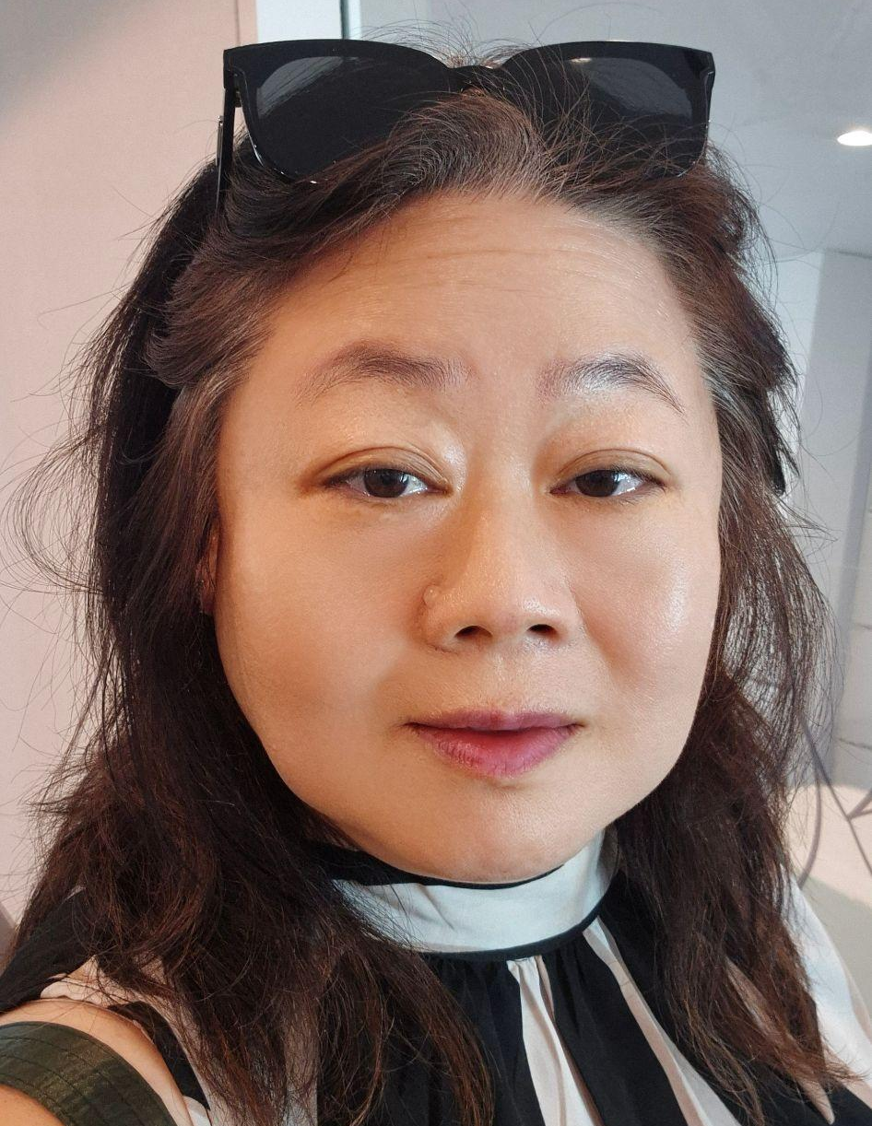

What I do
Experienced pharmacist with Singapore General Hospital overseeing Pharmacy Practice and providing direct patient care to solid organ transplant patients and renal failure patients. Joint appointment at MOH Chief Pharmacist’s Office advising on supply chain, new pharmacy practice, and any other pharmacy related matters. Also a caregiver.
Interest areas
Patient/Public empowerment, how to help patients to navigate the complex healthcare system, use of technologies and AI
What i would like to contribute as a mentor

I can provide insight and help teams to navigate the healthcare landscape, fine-tune the problem statement and test out the solution. Also providing the care giver perspective.

